# Firmware Update for Germanium Detector

The electronic system of the Germanium detector was based on a Xilinx 7z045 SoC, and detector data acquisition and processing are performed in the Programmable Logic of the SoC. A micro-SD card is used to store the firmware and related files (in **BOOT** sector) and a Linux system (in **rootfs** sector). A firmware file is a **.bit** file to be loaded by Linux to program the Programmable Logic of the SoC, which is done when the detector powers on. A **uEnv.txt** file in the **BOOT** sector records the name of the firmware file to be loaded.

The updating process includes adding a new firmware file and revising **uEnv.txt**. Both steps can be done either remotely or locally, depending on whether a valid network connection to the detector is available. The files related to the update are listed below.

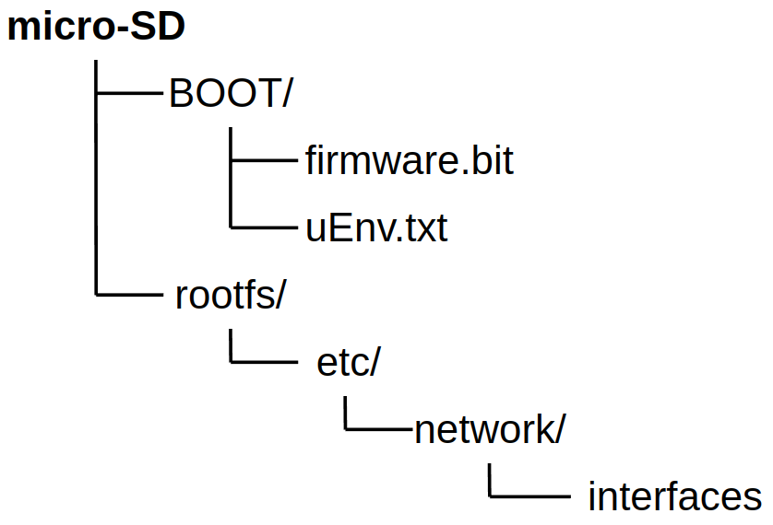

## Remote update

Remote update requires a valid network connection to the detector. Depending on network configuration (check **/etc/network/interfaces** in the **rootfs** sector), when the detector powers up, it gets either a dynamic IP address from a DHCP server, or the static IP address set in this file. To check the IP address when the detector is on:

1. Connect a computer to the console port (Micro USB) using a Micro USB cable.

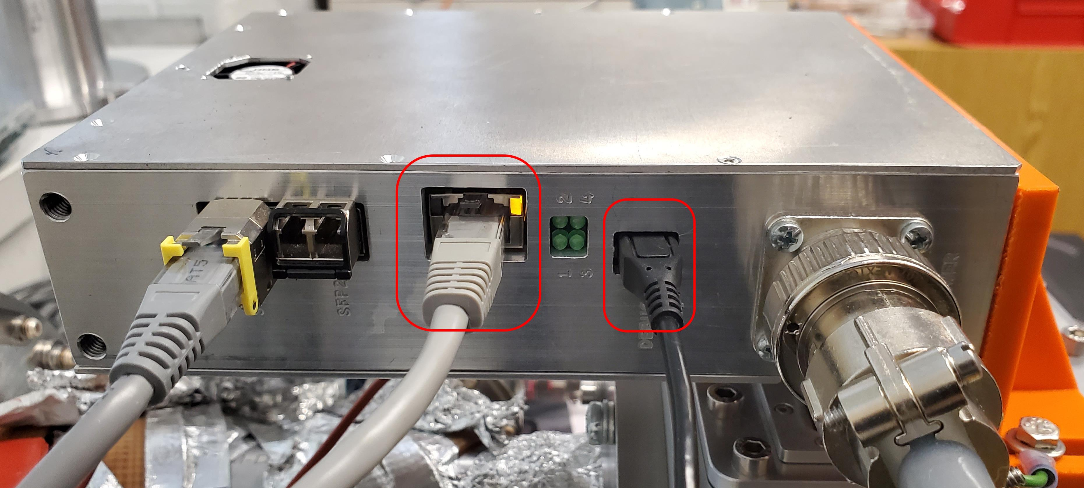

1. Open a terminal (e.g., minicom) on the computer.
2. Set correct parameters for the serial port corresponding to the USB connection (baud rate 115200, 8 data bits, 1 stop bit). Open the serial port.
3. Press Enter in the terminal. If it’s the first time logging in from the console port, a prompt for login appears. If seeing Linux prompt, skip to f).
4. Use the provided credential to log into the Linux system of the detector.
5. Run command:

$ ip a

This returns network configuration information, including the IP address of the network interface to be used (**eth0**).

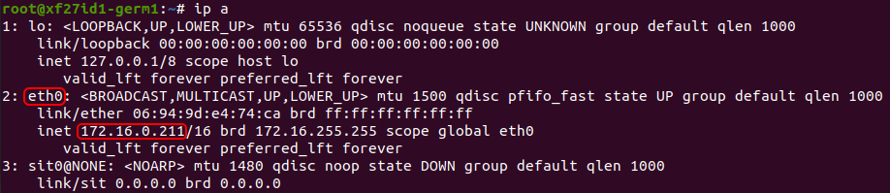

Now the firmware file can be uploaded from the computer with command:

$ scp new-firmware.bit root@ip-address:/boot/uboot/.

Next, revise **/boot/uboot/uEnv.txt**.Comment the line that loads the firmware file, e.g.,

# Comment: loadxbit=fatload mmc 0 ${btaddr} top_v18b_ajk.bit; fpga loadb 0 ${btaddr} ${filesize}

Add a new line to load the new firmware file:

loadxbit=fatload mmc 0 ${btaddr} top_v20_192_384.bit; fpga loadb 0 ${btaddr} ${filesize}

Save the file and exit. Reboot the detector to load the new firmware.

$ reboot

## 2. Manual update

Manual update requires the detector to be powered off to take out the micro-SD card.

***Caution: the detector shouldn’t be powered off for long time to avoid the electronic components being damaged by low temperature.***

This can be done as following:

1. Power off the detector.
2. Remove the cover of the detector circuitry housing.

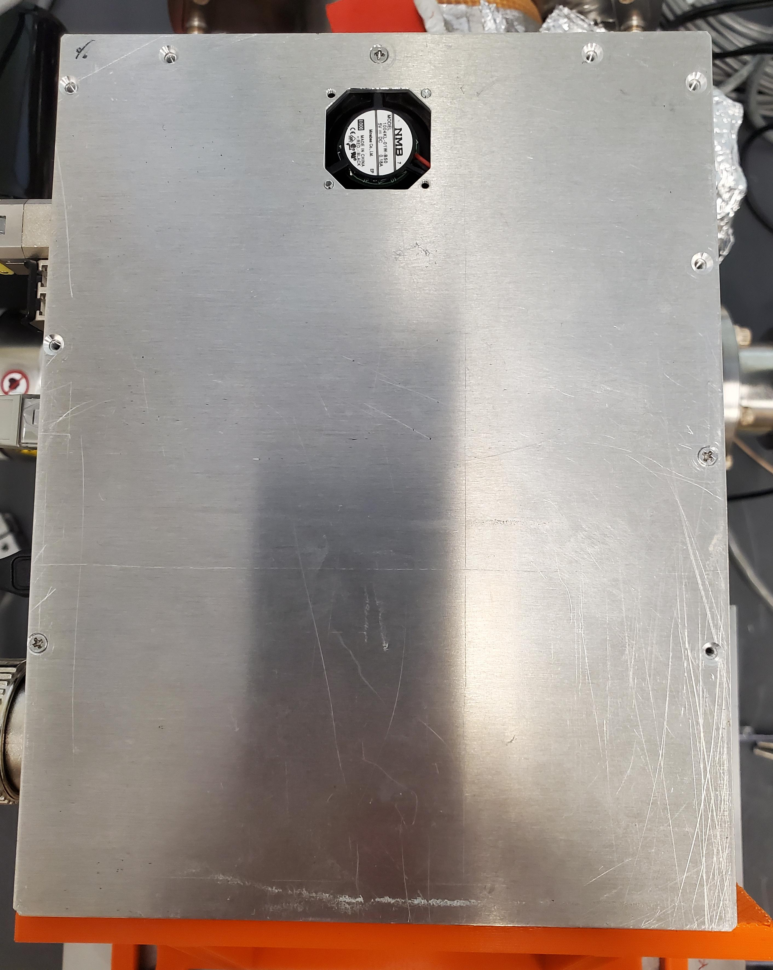

Be aware of the power cord of the cooling fan attached to the cover.

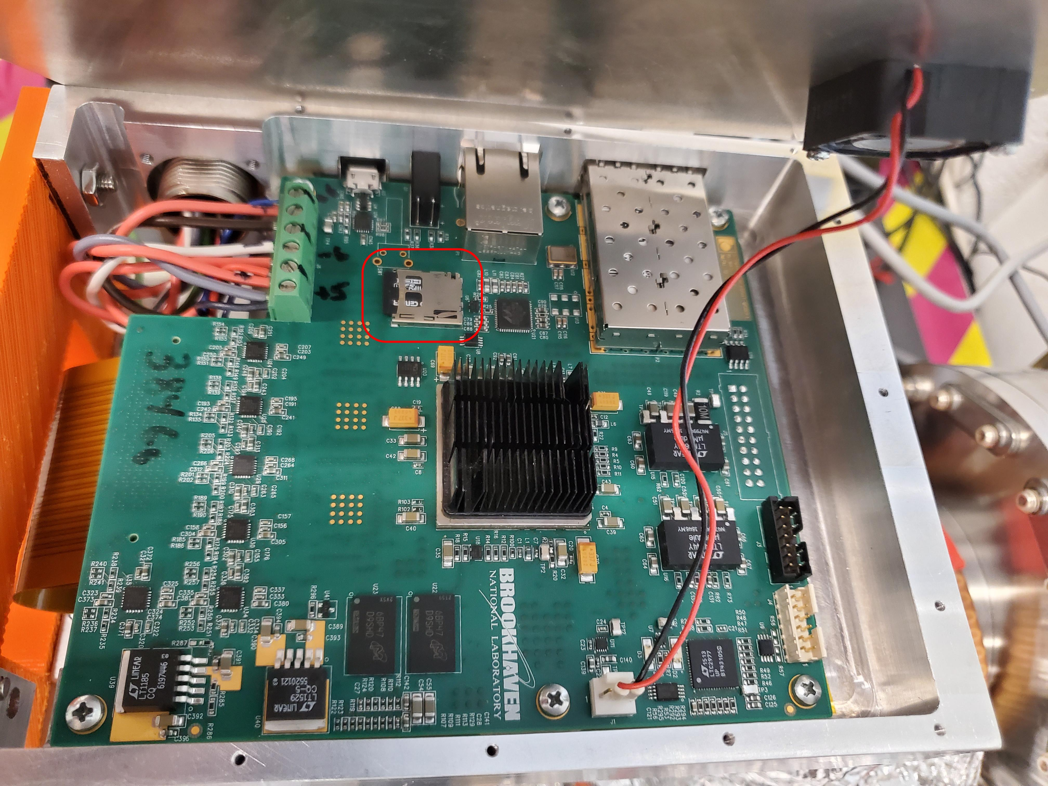

1. Take out the micro-SD card.
2. Insert the micro-SD card into a card reader.
3. Copy the firmware file to the BOOT sector of the micro-SD card. The destination directory may differ for different systems. In Debian/Ubuntu, use command:

$ cp new-firmware.bit /media/$user/BOOT/

1. Revise **uEnv.txt** in the **BOOT** sector as in the previous section.
2. Unmount the micro-SD card.
3. Replace the micro-SD card in the detector.
4. Replace the cover. Be aware of the connection of the power cord of the cooling fan.

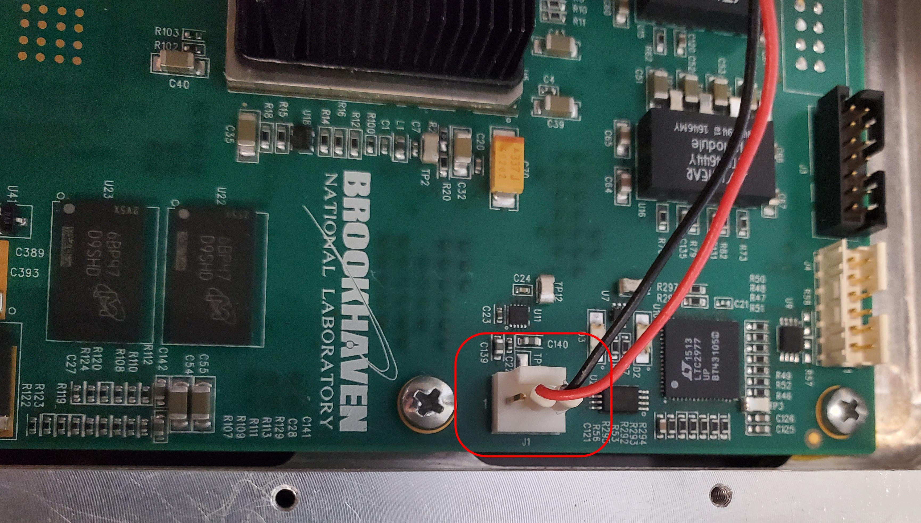

1. Turn on the power of the detector.